The Report of the Tikanga Toru Youth Commission to the 63rd General Synod / Te Hīnota Whānui
The Tikanga Toru Youth Commission (T3YC) continues to navigate the many routes that strengthen and support youth ministry. These infrastructures have assisted T3YC to invigorate maturity in its leadership, diversity in its partnerships, creativity in its development, and sustainability in its membership. The Canon overseeing the establishment of the T3YC since 2010, came out of twenty years of developing, resourcing, and reviewing youth ministry in a 3T context that:

- Governs Three-Tikanga Youth Structures
- Advocates for Youth Ministry throughout the Church
- Acts as the Standing Committee for the Tikanga Youth Synod
- Supports the Three-Tikanga Youth Commissioner, and

“He whakahau i te rangatahi kia pono ki a Te Karaiti i roto i tō tātou Hāhi Tikanga Toru,
disciples young people to be Christ-centred in our Three-Tikanga Church”

Foundational
T3YC reinforces its foundational principles driven by:

The Five Marks of Mission
T3YC works to promote a broad view of mission through:
- Proclaiming the Gospel
- Nurturing Believers
- Responding to Human Need
- Transforming the Unjust Structures in Society, and
- Caring for Creation

Kaupapa and Values:
- We exercise unreasonable manaakitanga; not only are you welcome, but we’re committed to bridging any obstacle that stands in the way of us being together in Christ.
- We work at high trust relationships; we are committed to speaking the truth in love, high trust relationships, being open, honest, and vulnerable.
- We listen to each other’s talanoa; together we have a thousand stories, of who we've been, who we are and who we will be—of God and God's action. Every story, no matter the inconvenience of hearing or telling it, is important.
- We operate with creativity and imagination; we have deep roots but we are not shackled to old ways of doing things. We are committed to asking, time and again, “What new work is God doing?”
- We aspire to be edge-walkers; as God goes before us all, we are committed to embracing our calling to go to the margins and beyond.
As T3YC launches itself into 2018, it is appropriate to acknowledge the strategic thinking, and missional aspirations of the hardworking individuals who have moved out into the missional fields of our province. For their valued service and contributions, we remain truly thankful.
2016 – 2017
Post GSTHW / Te Hīnota Whānui 2016, T3YC has had its usual membership changes. These changes have had governance, advisory, operational, and structural effects. In short, we have farewelled a Youth Liaison Bishop, Commissioner, Chairperson, National Youth Advisor, and some Youth Coordinators. This report briefly highlights these changes.

Staff changes

Farewell to the Commissioner
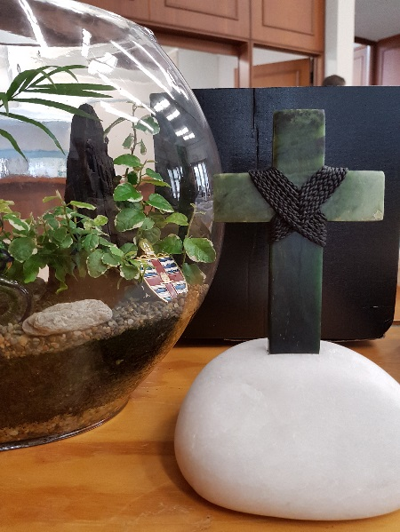
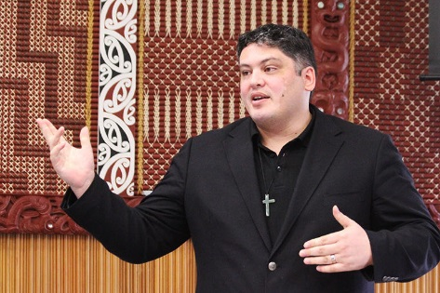
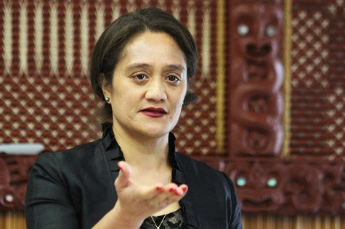
The Reverend Michael Tamihere served as T3YC’s Commissioner since its inception. T3YC organised a fitting send-off for Michael and Ala in August 2017. The heartfelt farewell speeches that day were testament to Michael’s gentle and endearing leadership to rangatahi (young people).
During his tenure Michael saw many members come and go. He spoke frankly and openly about the challenge that rotational memberships, hierarchy, isolation, and balancing his personal/professional life has been. In his closing kōrero on his working in a three tikanga role he said, “Everybody's space is nobody's space – and it can feel like that.” Michael has a knack for connecting with many people from many backgrounds in many contexts. These attributes heightened his passion to nurture rangatahi ministry. We are left with little doubt that Michael enjoyed his T3YC role and we pray God’s blessings upon Michael and his whānau knowing that he has much more to contribute, within the province, that is sure to enhance the ministry in others.
Ēhara tōu toa i te toa takitahi, engari he toa takitini
Your valour is not that of the individual, but that of the multitudes.

New Commissioner - 2018
In December 2018, T3YC advertised and interviewed for the role of a new Commissioner and warmly welcomes Jacqueline (Jax) Clark who officially took up her role as Commissioner in February. Jax hit the ground running at the 2018 TYS event and the first item on the agenda at the 2018 Tikanga Youth Synod was the formal welcome and commissioning.
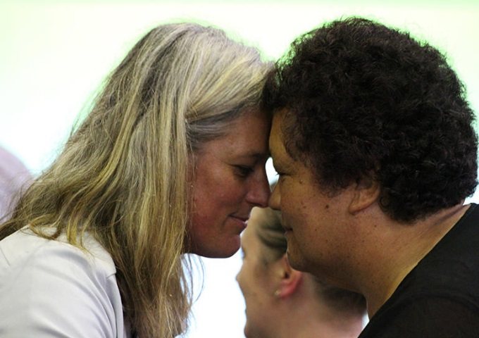
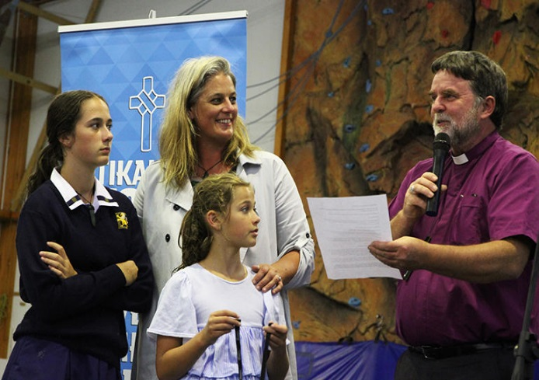

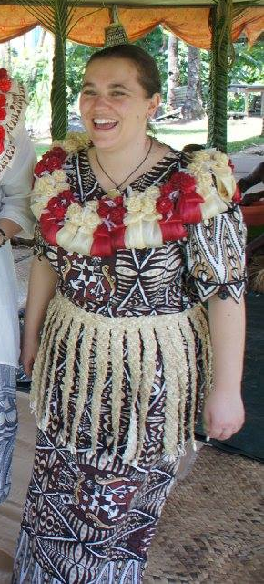
Jax had a gift she wanted to bestow on the synod. It was a framed photograph of a road sign. That sign has symbolic value, she reckons. A couple of weeks earlier, after her first day in her new job, she was snarled up in peak hour traffic when she noticed the road sign over the lane next to hers. Cars and buses were whizzing along that lane. That free-flowing lane, of course, is the T3 lane. Jax took that as a metaphor, a sign from the Lord even, that when the three tikanga truly mesh, things move and flourish. "If we choose to take that journey together," she told TYS, "I think we'll find we have a lot more movement.” Jax, who has a Bachelor's degree in Applied Theology, and has had many years' experience in youth ministry and community organising, is a member of St George's Epsom. Jax is based in the GSO Tuia building.

Project Manager
T3YC is extremely grateful to its Project Manager of 5-6 years, Karlina Brock-Smith. Karlina, who following Michael’s departure has had to carry a great deal of the commission’s workload throughout 2017, has been a central pou to the commission during her tenure. She has fully supported the role of the previous Commissioner and has demonstrated skills and talents young people can aspire to. Duties performed were often above and beyond her contractual responsibilities which has kept T3YC ‘ticking over’ as though the commission was fully staffed. It is with much regret that T3YC loses Karlina this year as she explores other pursuits on the highways and byways of God’s routes. We wish her every blessing in her endeavours and acknowledge her huge contribution to youth ministry in the regions, nationally, and most importantly in the provincial three tikanga environment for youth. Ngā mihi aroha ki a koe Karlina, mā Īhowa koe, me tou whānau, e manaaki e tiaki i ngā wā katoa.

Interim Manager
The Reverend Jacynthia Murphy was appointed the half-time Interim Manager for T3YC from July – December 2017. Jacynthia was asked to develop and implement a review of the commission that would conclude with a detailed report and recommendations. Additionally, she was tasked with progressing the phone application project that would assist young people to advance their liturgical and general use of te reo. Jacynthia encouraged T3YC participation at events and assisted with keeping operations going.
Jacynthia participated in 2017 engagements and events some of which are listed here:
- St John’s College Colloquium
A Hui was called to discuss and deliver perspectives Mira Martin Elmsly, Mele Prescott, and Darcy Perry offered a superb three tikanga lens into their collaborative youth work. Highlights included the sharing of their individual styles working towards a common cause. In other words, they overcome the geographical divide to work on projects that are of huge benefit to each of their youth ministries.
- Theological Hui
Representing T3YC at the Theological Hui was Zhane Tahau Whelan who sat with other Common Life representatives from St John’s College, Te Kotahitanga, Anglican Schools Office, and St John’s College Trust Board. “The college is a good experience and it is a joy to listen to all the views on education. Christian education is important. Many young people are lost because they rely on earthly matters and then fail. Christian education gives life, hope, and sets us free of the things that keep us down.”
- Board of Studies – St John’s College
T3YC continue to make ongoing contributions to the curriculum at St John’s College. Originally, T3YC delivered a semester paper on youth leadership, however, that has evolved into a block course delivered by Phil Trotter. The commission is encouraged to keep itself attached to the Board of Studies and develop a paper whereby the college is able to deliver a three tikanga youth paper well into the future.
- The Decade of Mission (DOM)
DOM brought together a diverse group of people to talk about and progress what DOM looks like and where it is headed. Both Karlina and Jacynthia attended the gathering which identified ways in which the province could be more intentional about mission. There were brief presentations on BOLD, Minita-a-Whānau, and other current initiatives. Robert Kereopa, CEO Anglican Missions Board, offered a challenge to all Dioceses and Hui Amorangi to consider signing up to a Season of Intentional Discipleship and Disciple-Making and to commit people, time and resources to it. T3YC have already identified missional strategies and will be supported by DOM to realise these.
- Council of Anglican Provinces of Africa (CAPA)
The Council of Anglican Provinces of Africa was to host the first ever Africa Youth Congress, in Nairobi Kenya, bringing together young people from all over Africa and the Worldwide Anglican Communion in December 2017. An invitation was received and T3YC selected Rosa Filoi and Kristy Boardman to go and share their experiences and successes on Youth Ministry in the dynamic times we live in, and lay the foundation for various networks for various aspects of holistic ministry. Sadly, in the leadup to the Kenyan Presidential Elections violent conflicts meant that the conference had to be postponed to April 2018. This was a lost opportunity for our provincial youth to interact, learn, and share in the valuable youth initiatives and storytelling.
- Raukura 2016/2017
Cambridge, 22-24 November
Raukura was an event that brought together T3YCs youth leaders. Key speaker, Rochelle Grace, delivered the 3DM model of Discipleship. These Lifeshapes are tools to help one live out a life of discipleship and mission. They are taken from biblical principles and teaching and put into simple ‘shapes’ to aid us in living out our Christian faith. Groups were asked to consider the different stages of discipleship, leadership & team development, modelled by Jesus, and come up with their own ‘Coke Ad’ that modelled this. Raukura included biblical studies, worship, and reflections. Activities of role-play, kayaking, and interactive kōrero/talanoa and 3DM would culminate in youth leaders going away with more relevant tools for youth ministry.
Hawke’s Bay, 20-21 Sep 2016
Thirteen National and Diocesan Youth Facilitators attended the 2016 Raukura with activities including orienteering, high ropes, and adventure based learning. Bad weather on the last day saw the cancellation of the Kayaking, replaced by indoor rock climbing. Evaluations were overwhelmingly positive in what was a shift in the style of delivery usually of classroom based learning.
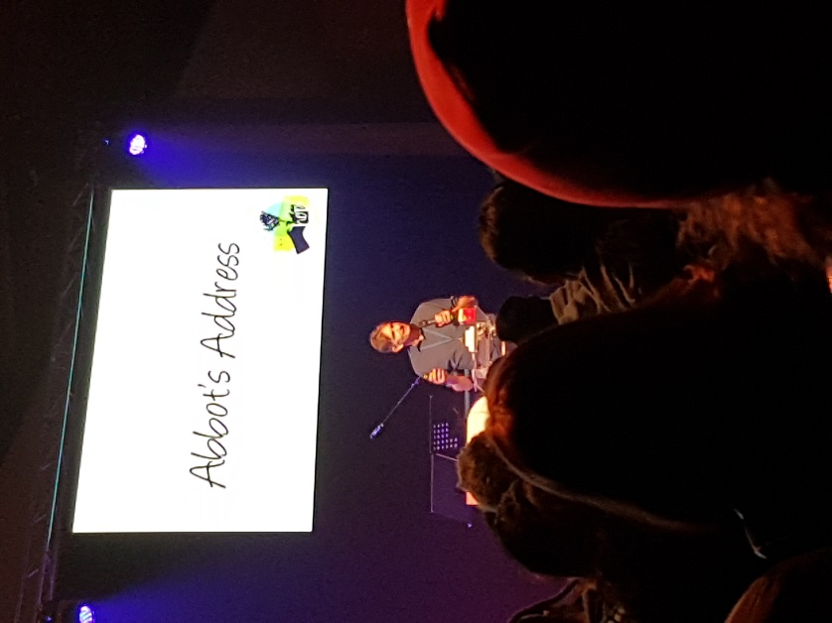
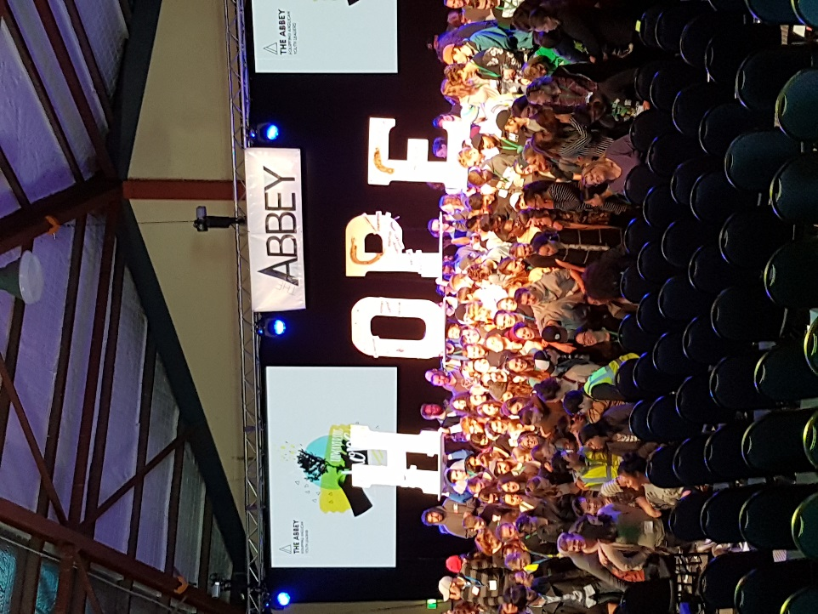
- The Abbey

The Abbey attracted a sizable number of youth seeking to enhance their ministry. It was vibrant, reflective, inspiring, and by sharing, participating, learning, and delivering numerous workshops and group discussions, youth were able to leave more equipped to carry out their ministries throughout the province. The highlights included interactive technology, keynote speakers, a panel to tackle the ‘hard’ issues, and worship music.
The gathering also farewelled Phil Trotter who has been the Tikanga Youth Advisor, for Tikanga Pākehā on the commission, for some years. Phil has been pivotal in the development of Building Intergenerational Communities an initiative also rolled out as a study paper at St John’s College. The Abbey was also one Phil’s pet ‘babies’ and it was here that youth were able to collectively farewell their comrade who has helped to form them for ministry.
“The one who sows generously will also reap generously. You will be enriched in every way for your great generosity; for the rendering of this ministry not only supplies the needs of the saints but also overflows with many thanksgivings to God.” 2 Corinthians 9:7-12
- TYE 2016
Fiji, 28 Nov - 5 Dec 2016
Around 50 young people and leaders from across the Province gathered in Fiji for TYE. The major content of TYE was built around the theme of ‘Climate Action,’ with a great opening address from ++Winston Halapua; keynote talks from Fei Tevi and Prof Beth Holland; an introduction to the PACE-SD’s IVA Framework and Gis-Map Tool; a trip to Leleuvia and tour of the Waqa Drua, the Uto Ni Yalo learning about its mission to revive and promote traditional and sustainable sailing methods; and a day with the community at Maniava – devastated by TC Winston and largely still waiting to be rebuilt a year later – where we presented gifts, put on a lunch for the community, and helped to dig the foundations of their new church with ++Winston and +Helen-Ann blessing the site and turning the first sod.
In the midst of this activity, space was made to build relationships and exchange the ways in which we worship, do youth ministry and mission, and learn about each other’s cultures – while immersed in the context of our hosts. The hospitality and welcome at the St Christopher’s compound in Nakasi and St Luke’s, Suva Point, and each of the many churches where different groups worshipped, and were hosted and feted, including all TYE at the Archbishop’s residence, was amazing. There was never enough space for adequate training in the IVA and GIS-Map tools from PaCE-SD.
In line with realising the motion on Climate Action passed at GSTHW it was proposed to get a selection of young people from across our 3T Church trained in these tools, with the ability to train others. This is the most practical, and easily measurable, initiative we could follow up on that would be transferrable to the local level on an issue that should be a priority for our whole church. TYE is probably the event at which we best provide and promote positive cross-Tikanga experiences and the deepening of inter-Tikanga understandings, relationships and collaboration.

- Henderson Auckland, Tikanga Youth Synod 2018
This year’s Tikanga Youth Synod took the form of a mock general synod, with the aim of exposing delegates to this type of forum, so they’ll be equipped to advocate for youth in the main decision-making forum of the church. The TYS representatives debated concerns that were first aired at last year's TYS, such as youth representation at General Synod, and the lack of awareness of mental health issues in our society, including church clergy and lay leaders. Discussions around the sharing of resources also took place and some time was given to raise new issues to be revisited at our next hui. The issues raised were formed into motions which will be submitted by youth representatives to the General Synod 2018. Approximately 50 delegates from all three tikanga attended this event and it was inspiring to see the commitment and passion our young people have for the leadership and organisation of the church.
Youth Stewards for 2018 were elected at Tikanga Youth Synod and will attend General Synod with Jax Clark in May. This is yet another opportunity for our Rangatahi to both be represented at this forum and to learn more about Church organisation and politics. Two representatives from each Tikanga will serve alongside Jax at this gathering and spend some time with youth leaders from the Taranaki region.

Commission membership changes

Liaison Bishop
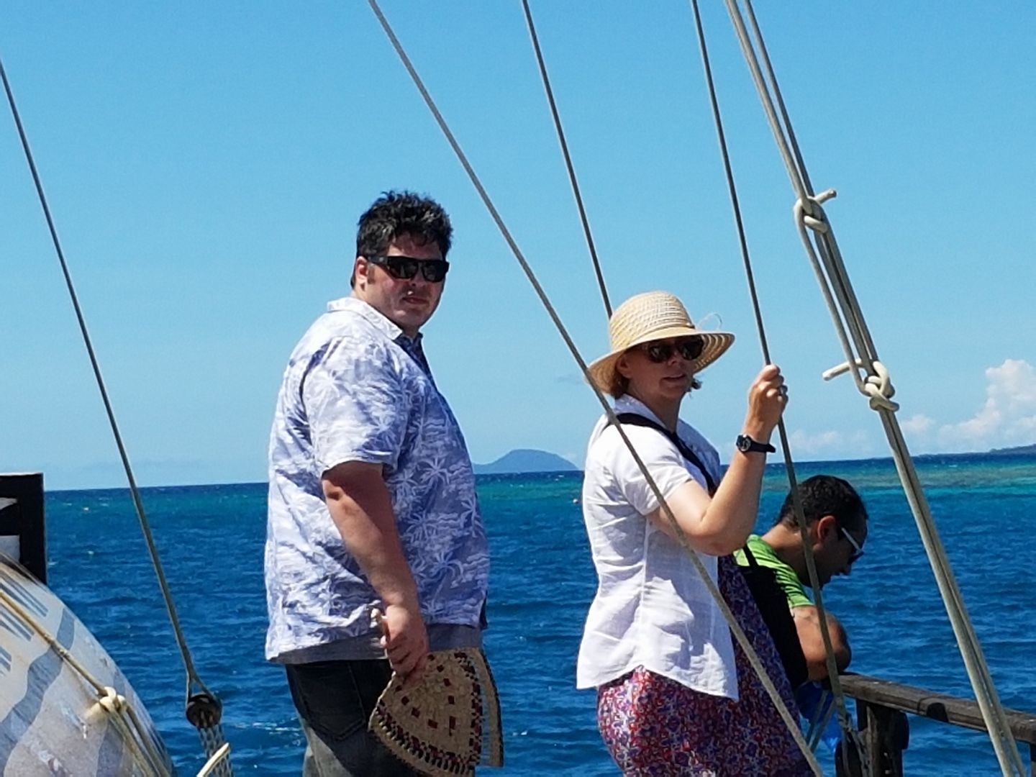
The Right Reverend Dr Helen-Ann Hartley accepted a call to become the Bishop of Ripon, in the Diocese of Leeds in England. She concluded her service in the Diocese of Waikato and Taranaki on Christmas Day 2017. Bishop ‘HA’ (as she often signed her emails) served as the liaison bishop and conduit between the House of Bishops and T3YC.
At an inaugural gathering of schools in her new Diocese Bishop HA said, “I have enjoyed supporting our Anglican schools, encouraging them in their work, and getting alongside the pupils and sharing in their lives – which has included activities like mountain biking and surfing, which I was not very good at! Sometimes all it takes is a mustard seed for the Kingdom of God to take hold.” Archbishop Philip adds, “while this call on Bishop Helen-Ann's life and ministry has come more quickly than I expected, it has all the marks of the work of the Holy Spirit. She has given herself wholeheartedly to leadership in this diocese and across our Province and I am deeply grateful for her partnership in ministry. I wish her God's richest blessing in her future role with all of the challenges of that large and busy region of the Diocese of Leeds.”
T3YC farewells +HA knowing that the young people of the Diocese of Leeds will benefit greatly from her desire and calling to empower and enable youth leaders into ministry. For her contribution to the Commission T3YC is extremely grateful. The many gems +HA will no doubt serve as tools for the youth ministry kete for many years to come. Nō reira e te Pīhopa Helen-Ann, ngā mihi aroha ki a koe mo ōu huarahi karaititanga ki Ingarangi. Tēnā koe.

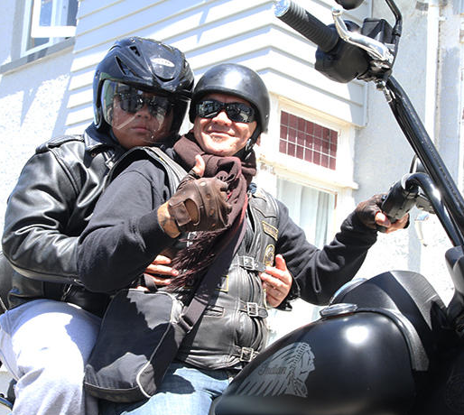
Chairperson
T3YC farewelled the Reverend Tony Brooking as its Chairperson. Tony has made some substantial contributions to the commission and its work. Tony was the fulltime curate at Holy Sepulchre Church in Grafton, and in addition to that full workload he chaired meetings, assisted with strategic planning & policy writing, supported events & projects, plus initiate the Te Reo phone application. Many of us fondly remember Tony arriving on his Harley Davidson, later to be an Indian, Motorcycle. Tony has served with the Redeemed Motorcycle Ministries as an evangelist for many years. Tony now serves with the chaplaincy team in the Army Defence Force. We thank Tony for his insightfulness and ministry to rangatahi by simply being a good role model.
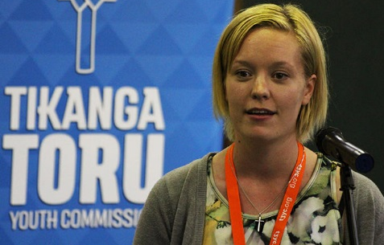
Equally, T3YC owes a great deal of gratitude to Kristy Boardman for stepping up from the Deputy Chair to fill the seat that Tony vacated. Kristy has had to juggle her rigorous University studies with the substantial responsibilities required of the acting chairperson. In coping with the imposed changes, Kristy has done an exemplary job of keeping T3YC consistent. Vinaka Kristy.

Coordinators
2017 farewelled the Diocesan Youth Coordinator for Polynesia, Reverend Sepiuta Hala’api’api, who enrolled at the Bishopdale College of Nelson, alongside her husband Patemosi Buekilagi, to further her theological studies. Sepi served on T3YC for many years and has been pivotal in the development, nurturing, and empowering of young Polynesian youth aspiring to serve not only at a Polynesian level but in a three tikanga context also. Sepi has had a good deal of influence in T3YC’s

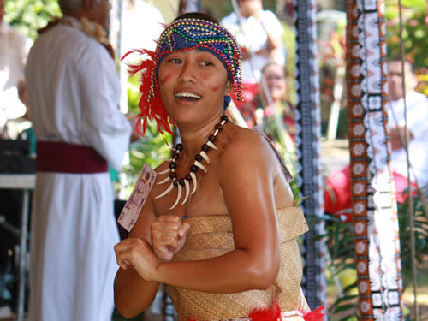
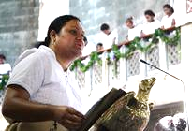

mission outreach through our province’s disaster response in the Pacific, in particular Fiji. We thank Rosa Filoi, herself a long-time participant of T3YC, has just completed an interim role, before moving to New Zealand and in February Ms Luisa Tu’itavake Havea was appointed the new Youth Director for Polynesia.
T3YC also farewelled the National Youth Advisor, Phil Trotter. Phil has contributed to many T3YC, IDCCG, Diocesan, and other bodies, within the provincial church. Phil has a lifetime of experience with young people and was a pioneer for the Tikanga Pākehā annual event, ‘The Abbey.’ T3YC thanks Phil and Carol Trotter for their lifelong contribution to T3YC’s training of young people, and is indebted to their children for sharing their parents with all other young ‘brothers and sisters’ in Christ. Ngā mihi aroha ki a koe, koutou mā.
Te Pīhopatanga installed their new Ringa Arataki for Te Whāriki Rangatahi, Reverend Rochelle Grace. Rochelle brings with her many years of youth ministry and coordination which helps to fulfil the commission in its three tikanga kaupapa.

Planning Ahead
- T3YC Review
At the suggestion of the House of Bishops T3YC agreed to undertake a diagnostic review of itself. No guidelines were set by the bishops therefore, the review applied an operational, technical, and functional lens to analyse the commission and its work, bearing in mind its Christ-centeredness also. The strategy to determine the health of the Commission was to take existing practices and overlay it with its aspirations to determine what is realistically achievable. The Commission has done just that and from this can now develop the necessary framework to build its capacity, validate its work, promote dialogue, and help to develop future strategic direction.
Funding was made available to develop a user-friendly reo resource to help bridge the cultural divide assisting with things like tikanga, language and other practices that provide barriers to good 3T communication and interaction. The Te Reo App will include sound bites for liturgical use made possible by Bishop Ben Te Haara’s recording of the 476 Eucharistic Service. This work is ongoing and is expected to be available for use some time in 2018.
T3YC developed a draft strategic plan that captures a vision based on the foundational principles of the commission and this province. The plan seeks to realise many of the aspirational youth ministry routes set by young people for young people. It is this forward planning that maintains the sustainability of youth ministry.
Policies have been written, implemented, and strengthened. These include the safety policy which covers an ambit of lawful, moral, and ethical measures to ensure the safety of young people.
- Strategic Plan
In 2017 the commission began drafting a strategic plan which has now traversed from being conceptual to a work-in-progress document being completed with fresh eyes, input, and vigour. Being 3T is both aspirational and invitational holding forth the promise and potential of being 3T together and inviting one another to do the hard work of wrestling with our relationship in honest and life-giving ways. However, where the overwhelming majority of us, day by day, are one Tikanga on the ground the challenge for T3YC remains to translate what we do at a 3T level to the flax roots.
Looking ahead, the T3YC has redoubled its commitment to ‘greening’ everything it does gearing its resources, work and events towards high school aged students and ensuring the environments we create are fit for them rather than defaulting to making young people only conform to fitting our environments as a Church.
The T3YC has also increased its commitment to strengthening strategic common life partnerships and vision-led collaboration at every level to support 3T relationships on the ground, disciple young people, and develop young leaders. Indeed, discipling young people (who disciple others) to be Christ-centred is considered to lay at the heart of the purpose for the T3YC and serves to form the basis of its kaupapa and mission.
- Te Reo Mobile App
In response to St John’s College Trust Board’s ‘new initiative’ funding T3YC secured some funding to develop and implement a Mobile App aimed at providing youth with liturgical resources and speechmaking tools in Te Reo. This exciting project is well underway and should be fully completed and downloadable later this year. It is envisaged that the App is not solely for the use of young people but for the wider church also.
- Policies, Job Descriptions, and Other
T3YC continues to maintain Safety Manuals, RAMS, Children’s Safety Policies, and other plans to ensure that the commission is operating at its optimum capacity in safety procedures, privacy, and protection measures comparable to the ACC’s safety policies released in 2015.
Additionally, responsibilities and roles within the commission are now measurable with the introduction of job descriptions with orientation procedures still to be developed fully. The new Commissioner and commission will have their work to do to ensure that those joining the commission are well informed, supported, and valued.
T3YC’s website is worth a look and offers its visitors a great insight into activities, both past and present, as well as many publications and directory. The Facebook page is an additional resource of current news and events.

Conclusion
T3YC is at the threshold of potential and now presents itself with an opportunity to navigate its future, based on its existing kaupapa, values, aspirations, collaborative leadership, 3tikanga-ness, events, passion, and of course the Canon. With that in mind, T3YC might now be better equipped to take what has been placed under the microscope and to bring the commission to that place where it wants and needs to be, even if that requires change, innovation, boldness, courage, and humility. In doing so, the commission will now have to ask itself, ‘where to from here’?

In looking at its kaupapa and over its work the T3YC recognises that it has benefitted different parts of the 3T youth network. It has created moments in time where it realises the promise of our 3T Church at events and through its work where boundaries vanish and three separate Tikanga are with and for one another before God. T3YC has also increased its commitment to strengthening strategic common life partnerships and vision-led collaboration at every level to support 3T relationships on the ground, disciple young people, and develop young leaders. Indeed, discipling young people (who disciple others) to be Christ-centred is considered to lay at the heart of the purpose for the T3YC and serves to form the basis of its kaupapa or Mission Statement:
“He whakahau i te rangatahi kia pono ki a Te Karaiti i roto i tō tātou Hāhi Tikanga Toru,
disciples young people to be Christ-centred in our Three-Tikanga Church”

Membership 2016-2018

Ex-officio
Youth Liaison Bishop: Right Reverend Dr Helen-Ann Hartley, Bishop of Waikato
General Secretary: Reverend Michael Hughes
General Synod Standing Committee Representative: Reverend Hannah Pomare
National Youth Advisor, Tikanga Pākehā: Mr Phil Trotter / Vacant
Ringa Arataki, Tikanga Māori: Reverend Rochelle Grace
Youth Coordinator, Tikanga Polynesia: Reverend Sepiuta Hala‘api‘api, Miss Rosa Filoi / Vacant

Nominated by the Tikanga Youth Synod, 2016

Tikanga Pākehā
Phil Trotter / Vacant
Miss Kristy Boardman
Mr Etienne Wain

Tikanga Polynesia
Reverend Sepiuta Hala‘api‘api, Miss Rosa Filoi / Vacant
Ms Liliani Havili, Ms Luisa Tu’itavake Havea

Tikanga Māori
Reverend Tony Brooking / Vacant
Reverend Rochelle Grace
Mr Zhane Tahau Whelan

Excerpt taken from Anglican Taonga News, 10 Feb 2018 http://www.anglicantaonga.org.nz/news/common_life/gridlock
http://www.anglicannews.org/news/2017

